# Installations:

# Genalyzer library & its Python bindings

1. Download the Windows Installer hère : [Genalyzer](https://github.com/analogdevicesinc/genalyzer/releases)
2. Python bindings available to install via PIP command in CLI:
   1. pip install --index-url <https://test.pypi.org/simple/> pylibgenalyzer
3. Documentation available here:

[Genalyzer Theory](https://github.com/analogdevicesinc/genalyzer/blob/main/doc/theory.md)

# Running a Python script on the Command line:

Open command prompt and change the current working directory to the path where the Python script is present.

Then, type in ***py file_name.py* or *python file_name.py*** to run that particular script.

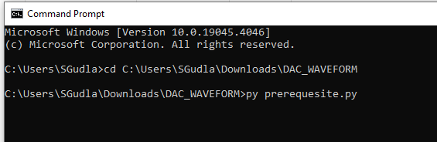

# Option 1: Using PyADI Python Interface

# Downloading the PyADI-IIO

* Before installing pyadi-iio make sure you have [libiio](https://github.com/analogdevicesinc/libiio) (v0.25) and [its python bindings](https://github.com/analogdevicesinc/libiio/blob/master/bindings/python/iio.py) (v0.25) installed.
* [Quick start - PyADI-IIO](https://analogdevicesinc.github.io/pyadi-iio/guides/quick.html)

# Note: If the PyADI drivers are not yet part of the repository (Partis unreleased)

After successful installation of Pyadi-iio library, go to site packages

C:\Users\SGudla\AppData\Local\Programs\Python\Python310\Lib\site-packages\adi

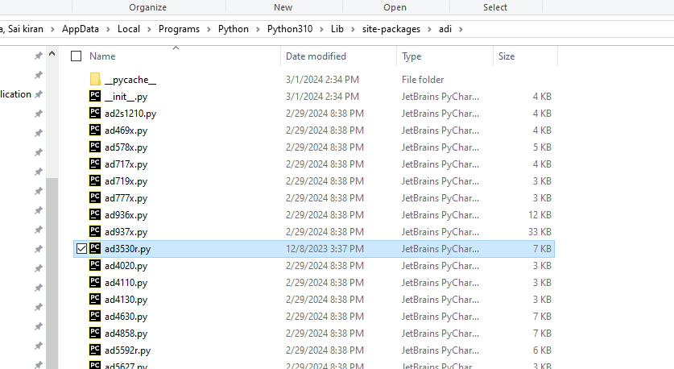

And paste the ad3530r.py driver into the adi folder.

Then, open the __init__.py file and add the line ***from adi.ad3530r import ad3530r***

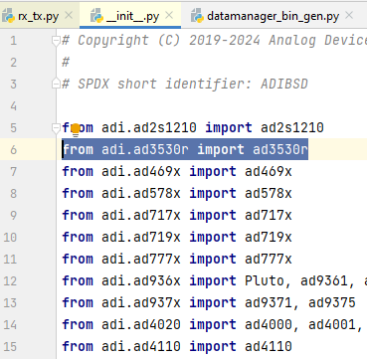

# Using the python cli tools for data streaming

After successful installation of genalyzer, PyADI-IIO lib and, all other requirements as specified in the requirements text (Using the PIP command: *pip install -r requirements.txt*),

**Note:** Run the prerequesites.py file initially to power-up the iio device before streaming data to the device as the device will be powered down by default/ Set the mode to normal operation using IIO oscilloscope

Follow the instructions mentioned here on the usage of adistream cli tools,

**Note:** In the commands, adistream.py can be replaced with the file name we want to run, for the latest versions, use adistream_final.py

* [ADI Stream for DACs](https://confluence.analog.com/pages/viewpage.action?pageId=916522245#UsingPyADICommandLineInterfaceTools-ADIStream:ForDACs)

# Option 2: Using IIO Osc :

# Installing IIO-Osc

* Install the IIO Osc latest version here [About IIO Osc](https://wiki.analog.com/resources/tools-software/linux-software/iio_oscilloscope)

# Using the DAC Data Manager on IIO Osc

* + The DAC data manager on the iio oscilloscope allows streaming data to supported iio devices
  + The input data file can be a .bin or a .mat file

# Creating .bin files using Python script

* + Run the Python script “datamanager_bin_gen.py” to generate binary file containing waveform data for streaming
  + 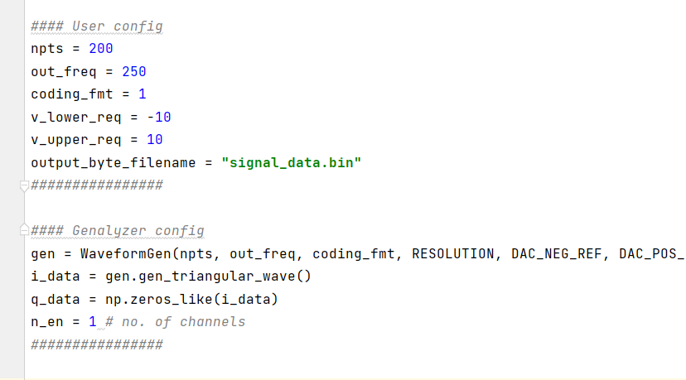
  + User settings can be configured on the user config section and waveform related settings like sine/traingular can configured on the Genalyzer config section
  + 

# Loading the Data

* Open the DAC Data Manager as shown below on the iio oscilloscope

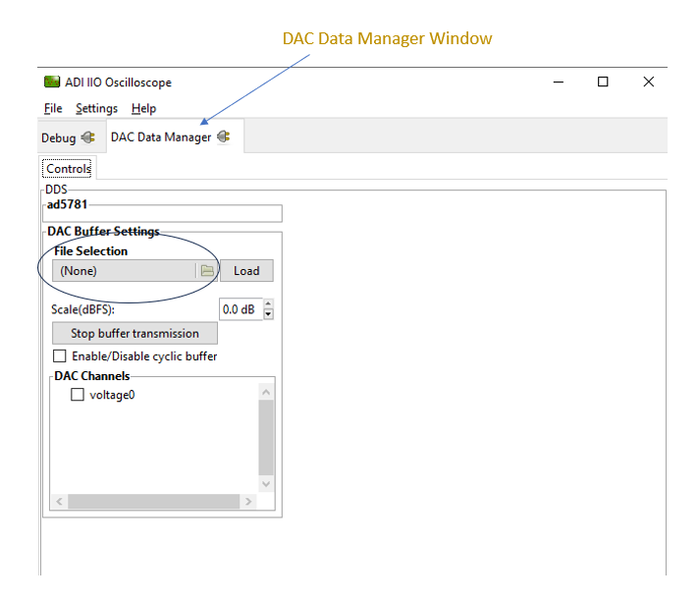

* Click on the File Selection section to input the wavefrom data binary file created
* 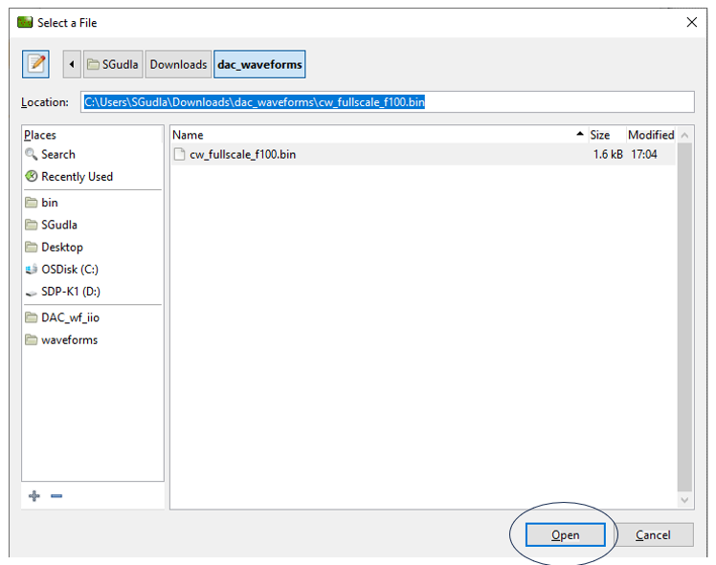
* Copy the binary file path and paste it on the Location section and click Open
* 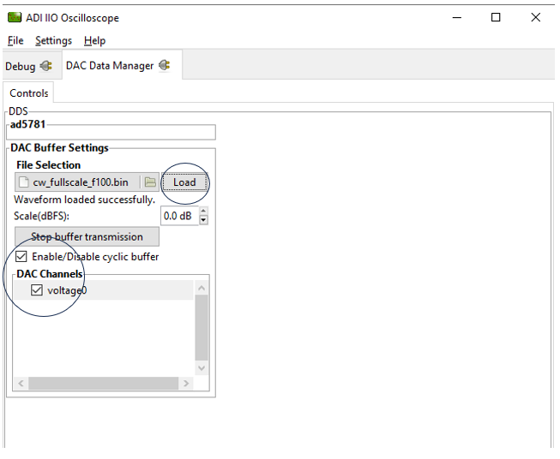
* Enable the channels checkbox to select the channels required for data streaming

**Note:** The input data file shall have data according to the number of active channels required and otherwise may result in an error or wrong data streaming

* Then, enable the cyclic buffer mode for cyclic streaming of data
* Load the data by clicking then Load button ; « Waveform loaded successfully appears if everything goes fine »
* 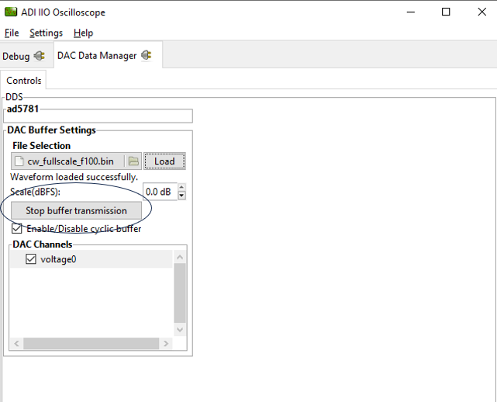
* To stop the data transmission, click on the Stop buffer transmission

# Option 3: Using Precision Toolbox Matlab Interface :

# Installation and Usage

[Installation - Analog Devices, Inc. Precision Toolbox (analogdevicesinc.github.io)](https://analogdevicesinc.github.io/PrecisionToolbox/master/install/)